Jaca (Aragon) SPAIN
24-27 june 2014
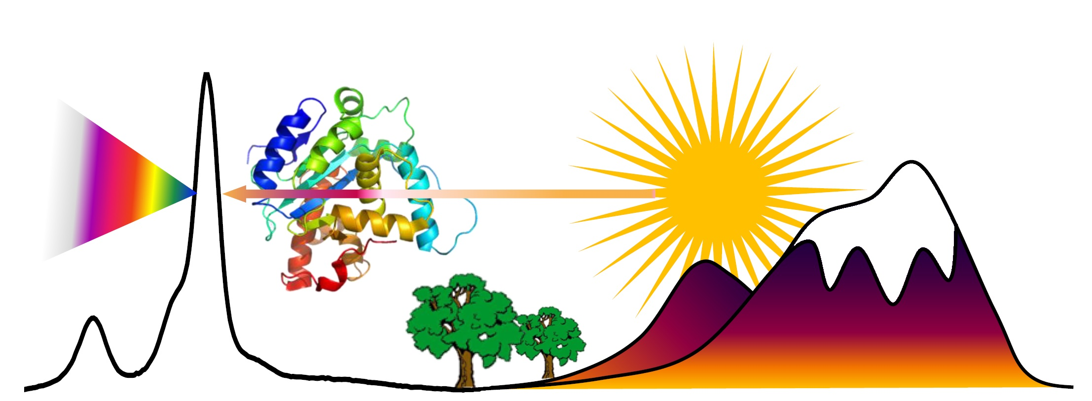
Summer School on Biospectroscopy
Escuela de Verano Bioespectroscopía
École d’Été Biospectroscopie

Registration form / Formulaire d’inscription

Please fill in the form below and e-mail it to: s.sanchez.cortes@csic.es /belen.hernandez@univ-paris13.fr
Please send us (scanned as attached file) a document justifying your bank wire transfer, clearly reporting your ID personal code. Veuillez remplir ce formulaire et l’envoyer par e-mail à : s.sanchez.cortes@csic.es ou belen.hernandez@univ-paris13.fr Veuillez nous envoyer par e-mail le document justificatif de votre transfert bancaire, en indiquant votre code ID.

- Title / Titre (Pr./Dr./Mr./Mrs./Other/Autre): Mr.
- Family name / Nom :
- First Name / Prénom : ID personal CODE* :
- Affiliation/Rattachement : Professional address / Adresse professionnelle:
- City, country/Ville, pays :
- Zip Code / Code Postal :
- Telephone / Téléphone :
- e-mail :
- Person with whom I desire to share room / Personne avec qui vous souhaitez partager la chambre:

- Title of your contribution (if you asked for an short oral contribution)
…………………………………………………………………………………………………………………………………………
- Would you like to submit your contribution for publication in the journal “Optica Pura y Aplicada” (especial issue)/Souhaiteriez-vous soumettre votre contribution pour publication dans un numéro spécial du journal « Optica Pura y Aplicada) (articles en anglais)

□ YES □ NO

- Accompanying persons/ Nombre d’accompagnants :

1) Family Name, First name/ Nom, Prénom:

……………………………………………..

- Registration fees/ Tarifs d’inscription:

Before 15/06/2014
Avant 15/06/2014
Student rate / Tarif normal | 250 €
Norma rate/ Tarif normale | 350 €
Accompanying person/ Accompagnants | 250 €

Normal and student rates include: access to the conference, 4 days accomodation, breakfast, coffee breaks, lunches, and excursion/Ces droits d’inscription comprennent : l’inscription à l’école, lelogement, petit déjeuner, pauses café, les repas du midi ainsi que l’excursion

TOTAL TO BE PAYED: ……………………………. €

Corresponding to (n°) …………. Registration (normal rate)/ Inscriptions (tarif normal)
…………. Registration (student rate) /Inscriptions (tarif étudiant)
………….. Accompanying persons / Accompagnants

Please note that only payments by bank wire transfer will be accepted (see below for bank transfer identity).

Sent before June, 15th 2010, together with the payment receipt, by e-mail to:
s.sanchez.cortes@csic.es
or
belen.hernandenz@univ-paris13.fr
RegiFees must be paid by bank transfer to: "SPANISH OPTICAL SOCIETY", with the subject: Registration Jaca 2014, your
Personal code, and completed name to the bank account:
ornn
C/C: ES68 0049 1803 5928 1030 4088 (Bank: Santander Central Hispano, Serrano 57, 28006 MADRID

CLEARLY INDICATE IN THE “OBJECT” OF YOUR TRANSFER: “REGISTRATION JACA 2014” together with your ID. PERSONAL(s) CODE(s) ATTRIBUTED DURING THE PRE-REGISTRATION PHASE. Send by e-mail the scanned document justifying your bank wire transfer, clearly reporting your ID personal code

